

**Department of Computer Science and Engineering**

**Project Report**

**Course Code: CSE 104-L**

**Course Title: Electrical Circuit Analysis**

**Spring 2023**

**Project Title: RC Car**

**Group Name:**

|  |  |  |  |  |
| --- | --- | --- | --- | --- |
| **Name** | **ID** | **Section**  **[Theory]** | **Section**  **[Lab]** | **Instructor** |
|  |  |  |  |  |
|  |  |  |  |  |
|  |  |  |  |  |
|  |  |  |  |  |

**Abstract**

The scope of this project revolves around building a remote-controlled vehicle (RC vehicle) by utilizing Arduino UNO and other parts. A Bluetooth remote control application is used to operate the bot through an Android device. It can move forward, backward, left, and right. The architecture was built by designing and building the car's chassis and joining different hardware with wires and a code was applied to the Arduino Uno in order to control the car's motion. The software development process, the hardware which was used, and the difficulties encountered during the project are all described in detail in the report. In addition, the report discusses the technology behind RC cars and their potential uses in the future.

**Introduction:**

**The RC (Remote Controlled) car project is an innovative prototype vehicle that utilizes wireless remote technology and an Arduino UNO microcontroller board as its main processing unit. The project aims to explore the potential benefits of incorporating microcontrollers in the design and development of remote-controlled devices.**

**The RC car is a four-wheeled vehicle that can be controlled remotely using a wireless remote. The use of microcontroller technology enables the car to perform complex tasks and respond to various input signals from the remote control. The project involves the design and construction of the RC car, as well as the programming of the microcontroller to enable the car to respond to the user's commands.**

**The objective of this project is to investigate the advantages of using microcontrollers in remote-controlled device design and development. Microcontrollers offer several benefits over traditional circuits and controls, including improved efficiency, greater precision, and enhanced functionality. By exploring the potential of microcontrollers in the context of remote-controlled devices, this project seeks to contribute to the growing body of knowledge in this area and provide insights for future research and development.**

**This project report will provide a detailed description of the RC car design and construction process, as well as an overview of the microcontroller programming and testing procedures. The report will also discuss the key findings and insights from the project, and offer recommendations for future research and development in the field of remote-controlled devices**

**Real-life examples of RC cars: RC cars have practical uses in various fields, such as hobbyist racing, industrial inspections, education, surveillance and security, and transportation. For example, hobbyist racing events are organized by clubs or organizations and can range from casual to competitive. In industrial settings, RC cars can be used for remote inspections and monitoring to improve safety, reduce downtime, and increase efficiency. RC cars are also used in education to teach children about robotics and automation, and in research and development to testing new technologies. Additionally, RC cars can be used for surveillance, security, and transportation tasks to provide cost-effective and efficient solutions.**

**Project Compilation:**

The RC car project involves the design and development of remote-controlled cars that can be controlled using smartphones or other smart devices. These cars use Bluetooth or other wireless protocols to communicate with the controlling device and allow users to control their movements and functions. The project aims to explore new design possibilities and to create innovative solutions that can be used in a range of real-life applications, such as hobbyist models, industrial models for remote inspection and monitoring tasks, and educational tools for teaching children about robotics and automation. The project has the potential to make a significant contribution to the field of robotics and automation and offers practical applications and educational benefits.

**Materials Used:**

|  |  |  |  |
| --- | --- | --- | --- |
| **Main Materials** |  | **Model Pictures:** |  |
|  |  |
|  |  |  |
|  |  |  |  |
| 1. Arduino Board 2. Bluetooth Module 3. Motor Drive Shield 4. DC Gear Motor 5. Stainless Steel Nails and Nylon Jumpers 6. Connecting Wires and Jumper Cables |  |  |  |

**Code**:

Software Writing code for the Arduino board to control the motor driver module and receive commands from the Bluetooth module is the software portion of the project. The Arduino IDE was used to write the code, which can be broken down into the following parts:

Initialization: This section establishes the Bluetooth module's communication protocol and initializes the Arduino board's pins.

Control of Motors: This part controls the engines of the vehicle by getting orders from the Bluetooth module and utilizing the engine driver module to drive the engines.

Bluetooth Connectivity: This section transmits commands to the motor control section from the Bluetooth module.

1)Initialize the Arduino barricade and set the Bluetooth module.

2) Wait for the Bluetooth module's commands.

3) Examine the type of the command that is received.

4) Send the command to the motor driver module if it is a motor control command.

5) In the event that the command is a Bluetooth command, respond to the remote device.

Code implemented:

#include<SoftwareSerial.h>

SoftwareSerial MyBlue(0,1); else if(t == 'L')

chartt; {

digitalWrite(13,HIGH);

void setup() digitalWrite(12,LOW);

{ digitalWrite(11,LOW);

pinMode(13,OUTPUT); digitalWrite(10,HIGH);

pinMode(12,OUTPUT); }

pinMode(11,OUTPUT);

pinMode(10,OUTPUT); else if(t == 'R')

MyBlue.begin(9600); {

} digitalWrite(13,LOW);

digitalWrite(12,HIGH);

void loop() digitalWrite(11,HIGH);

{ digitalWrite(10,LOW);

}

if(MyBlue.available())

{

t = MyBlue.read(); else if(t == 'S')

} {

digitalWrite(13,LOW);

digitalWrite(12,LOW);

if(t == 'F') digitalWrite(11,LOW);

{ digitalWrite(10,LOW);

digitalWrite(13,HIGH); }

digitalWrite(12,LOW); delay(100);

digitalWrite(11,HIGH); }

digitalWrite(10,LOW);

}

else if(t == 'B')

{

digitalWrite(13,LOW);

digitalWrite(12,HIGH);

digitalWrite(11,LOW);

digitalWrite(10,HIGH);

}

**Cost Breakdown**:

|  |  |  |  |  |
| --- | --- | --- | --- | --- |
| ***SL*** | ***Component*** | ***Quantity*** | ***Unit Cost (BDT)*** | ***Total (BDT)*** |
|  |  |  |  |  |
| 1 | Arduino Uno R3 | 1 | 950 | 950 |
| 2 | 4WD Smart Robot Chassis Kit | 1 | 950 | 959 |
| 3 | Arduino Bluetooth Module (HC-06) | 1 | 280 | 280 |
| 4 | 3.7 V Li-on Battery | 8 | 80 | 640 |
| 5 | L298n Motor Driver | 1 | 180 | 180 |
| 7 | Universal Dual Li-ion Battery Charger | 1 | 200 | 200 |
| 8 | Jumper Wire Set | 2 | 100 | 200 |
|  |  |  | **Total Cost (BDT)** | 3400 |

**Hardware:**

**UNO:**

Arduino Uno is a microcontroller board that has revolutionized the field of electronics and robotics. At the heart of the Arduino Uno lies the Atmel ATmega328P microcontroller, which is responsible for the board's processing power and functionality. The Arduino Uno is an open-source hardware and software platform, which means that it is freely available to anyone who wishes to use it for their projects.

One of the most notable features of the Arduino Uno is its versatility. The board can be programmed using a simple programming language that is similar to C++, making it accessible to beginners and experts alike. This flexibility enables users to create a wide range of projects, from simple LED displays to complex robotics systems.

Another advantage of the Arduino Uno is its ease of use. The board can be powered by a USB cable or an external power source, making it portable and easy to set up. Additionally, the board is equipped with a range of input and output pins that can be used to interface with a variety of sensors, actuators, and other components.

The Arduino Uno also features a robust ecosystem of hardware and software add-ons, such as shields, libraries, and development environments. These add-ons can extend the functionality of the board and simplify the development process.

Despite its many advantages, the Arduino Uno does have some limitations. For example, the board has a limited amount of memory and processing power, which may restrict the complexity of projects that can be developed using it. Additionally, the board may not be suitable for certain applications that require higher levels of reliability and safety.

Overall, the Arduino Uno is a powerful and versatile microcontroller board that has transformed the field of electronics and robotics. Its ease of use and flexibility make it an excellent tool for both beginners and experts, and its open-source nature ensures that it will continue to evolve and improve over time.

**Circuit Diagram:**

Future Uses of RC Car:

The RC car project has the potential to be utilized in various applications in the future. One potential use is in the field of autonomous vehicles, where the technology used in the RC car could be adapted for larger-scale vehicles. Another potential application is in the field of robotics, where the RC car could serve as a platform for developing and testing autonomous robots. Additionally, the RC car could be used for educational purposes, as a tool for teaching students about programming and robotics.

Discussion about RC Car Technology:

The RC car project represents a significant advancement in the field of remote-controlled devices, due to the use of microcontroller technology. Microcontrollers offer several advantages over traditional circuits and controls, such as improved efficiency and functionality. Additionally, the use of wireless remote technology allows for greater flexibility and range in controlling the vehicle.

However, there are also some limitations to the current technology used in the RC car project. For example, the range of the wireless remote may be limited, which could affect the usability of the vehicle in certain applications. Additionally, the processing power of the Arduino UNO microcontroller may be insufficient for more complex tasks.

Overall, the RC car project represents a significant step forward in the design and development of remote-controlled devices and offers great potential for future research and applications in the field.

**Final Product of the hardware:**

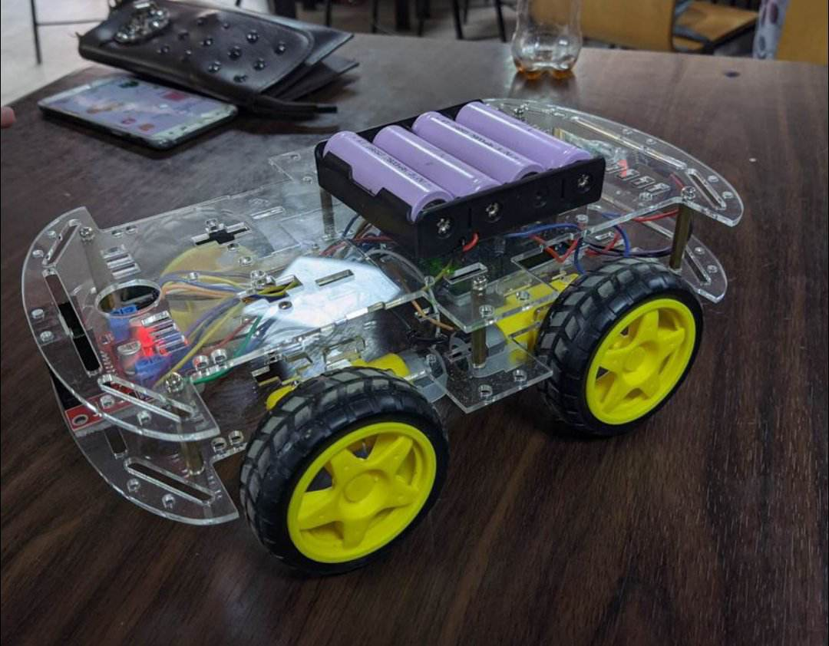

**Recommendations:**

In future iterations of the RC car project, the following improvements can be made:

1. Use a more powerful motor driver module to allow for greater speed and torque.
2. Use a more advanced microcontroller board with more processing power to allow for more complex commands and functions.
3. Implement a sensor system to allow for autonomous driving and obstacle avoidance.

Limitations and **Problems Faced:**

1. Limited battery life: The 9V battery used to power the car had a limited lifespan and required frequent recharging.
2. Limited speed and torque: The L298N motor driver module used in the project had limited capabilities and could not achieve high speeds or torques.
3. Bluetooth connection issues: The Bluetooth module had difficulty maintaining a stable connection with the remote device, leading to intermittent control issues.
4. This project wasn’t budget-friendly. If the prices of the materials used were more cheaper, it would have been possible to upgrade the vehicle a lot more

Functions and Library:

The following functions and libraries were used in the RC car project:

Software Serial Library: This library was used to set up the Bluetooth module communication protocol.

Motor control functions: These functions were used to control the motors of the car using the L298N motor driver module.

Bluetooth command functions: These functions were used to receive and interpret commands from the Bluetooth module.

Conclusion

The RC car project demonstrated the application of microcontrollers in the design and development of remote-controlled devices. The project successfully achieved its objective of creating a prototype vehicle that could be remotely controlled using a wireless remote. The limitations and problems encountered during the project highlighted areas for improvement in future iterations of the design.

**References:**

1. <https://create.arduino.cc/projecthub/samanfern/bluetooth-controlled-car-d5d9ca>
2. <https://create.arduino.cc/projecthub/JANAK13/bluetooth-controlled-car-2c60e9?ref=search&ref_id=Elelctric%20Car%20with%20Bluetooth%20c> [ontrol&offset=2](https://create.arduino.cc/projecthub/JANAK13/bluetooth-controlled-car-2c60e9?ref=search&ref_id=Elelctric%20Car%20with%20Bluetooth%20control&offset=2)

1. <https://www.instructables.com/Smartphone-Controlled-RC-Car-Using-Arduino/>